JS Applications Exam – CarTube
You are assigned to implement a Web application (SPA) using JavaScript. The application should dynamically display content, based on user interaction and support user profiles and CRUD operations, using a REST service.

Overview
Implement a front-end app (SPA) for viewing and managing car listings. The application allows visitors to browse through different car ads. Users may register with a username and password, which allows them to create their own ads. Ad authors can also edit or delete their own publications at any time.

Technical Details
You are provided with the following resources:
- Project scaffold: A package.json file, containing a list of common dependencies. You may change the included libraries to your preference. The sections devDependencies and scripts of the file are used by the automated testing suite, altering them may result in incorrect test operation.
To initialize the project, execute the command npm install via the command-line terminal.
- HTML and CSS files: All views (pages) of the application, including sample user-generated content, are included in the file index.html, which links to CSS and other static files. Each view is in a separate section of the file, which can be identified by a unique class name or id attribute. Your application may use any preferred method (such as a templating library or manual visibility settings) to display only the selected view and to navigate between views upon user interaction.
- Local REST service: A special server, which contains sample data and supports user registration and CRUD operations via REST requests is included with the project. Each section of this document (where applicable) includes details about the necessary REST endpoints, to which requests must be sent, and the shape of the expected request body.
For more information on how to use the included server, see Appendix A: Using the Local REST Service at the end of this document.
- Automated tests: A complete test suite is included, which can be used to test the correctness of your solution. Your work will be assessed, based on these tests.
For more information on how to run the tests, see Appendix B: Running the Test Suite at the end of this document.
Note: When creating HTML Elements and displaying them on the page, adhere as closely as possible to the provided HTML samples. Changing the structure of the document may prevent the tests from running correctly, which will adversely affect your assessment grade. You may add attributes (such as class and dataset) to any HTML Element, as well as change "href" attributes on links and add/change the method and action attributes of HTML Forms, to facilitate the correct operation of a routing library or another method of abstraction. You may also add hidden elements to help you implement certain parts of the application requirements.

Application Requirements

Navigation Bar (5 pts)
Navigation links should correctly change the current page (view). Guests (unauthenticated visitors) can see the links to the All Listings page, as well as the links to the Login and Register pages. The logged-in user navbar should contain the links to the All Listings page, the Create page and a link for the Logout action.
Guest navigation example:
User navigation example:

Login User (5 pts)
The included REST service comes with the following premade user accounts, which you may use for development:
{ "username": "Peter", "password": "123456" }
{ "username": "John", "password": "123456" }
The Login page contains a form for existing user authentication. By providing a username and password, the app should log in user in the system if there are no empty fields.
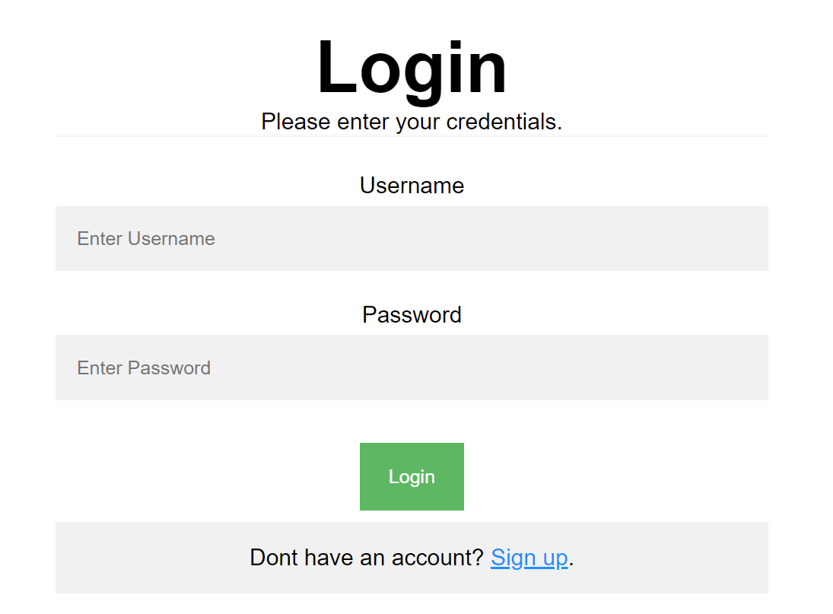
Send the following request to perform login:
Method: POST
URL: /users/login
Required headers are described in the documentation. The service expects a body with the following shape:
{
username,
password
}
Upon success, the REST service will return information about the existing user along with a property accessToken, which contains the session token for the user – you need to store this information using sessionStorage or localStorage, to be able to perform authenticated requests.
If the login was successful, redirect the user to the All Listings page. If there is an error, display an appropriate error message, using a system dialog (window.alert).

Register User (10 pts)
The Register page contains a form for new user registration. By providing a username and password, the app should register a new user in the system if there are no empty fields.
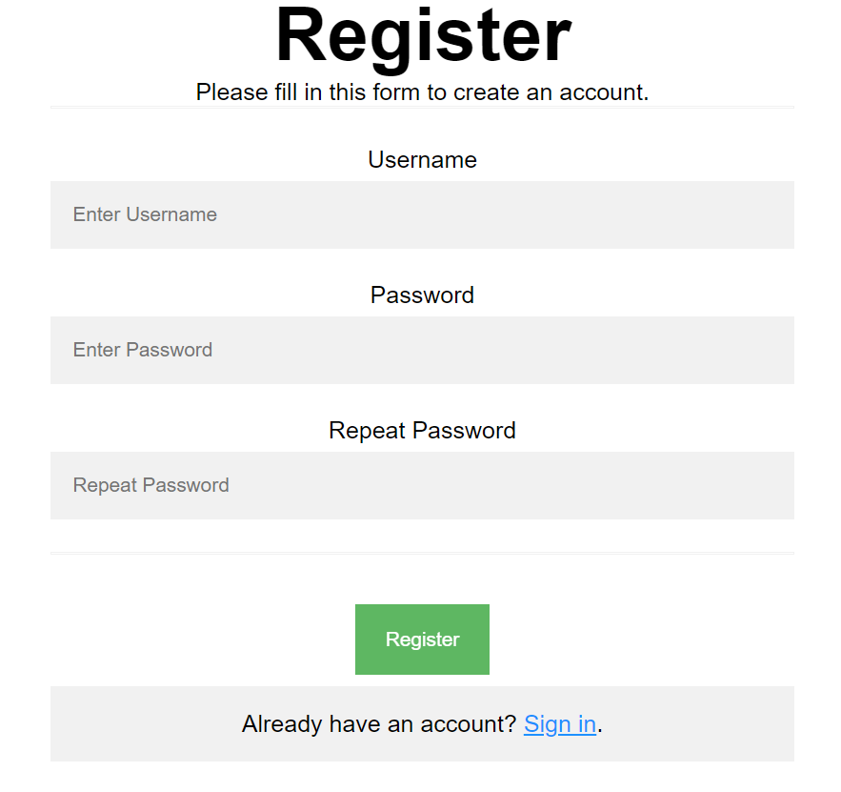
Send the following request to perform registration:
Method: POST
URL: /users/register
Required headers are described in the documentation. The service expects a body with the following shape:
{
username,
password
}
Upon success, the REST service will return the newly created object with an automatically generated _id and a property accessToken, which contains the session token for the user – you need to store this information using sessionStorage or localStorage, to be able to perform authenticated requests.
If the registration was successful, redirect the user to the All Listings page. If there is an error, or the validations don’t pass, display an appropriate error message, using a system dialog (window.alert).

Logout (5 pts)
The logout action is available to logged-in users. Send the following request to perform logout:
Method: GET
URL: /users/logout
Required headers are described in the documentation. Upon success, the REST service will return an empty response. Clear any session information you’ve stored in browser storage.
If the logout was successful, redirect the user to the Home page.

Home Page (5 pts)
All users should be welcomed by the Home page, where they can redirect to the Listings view.
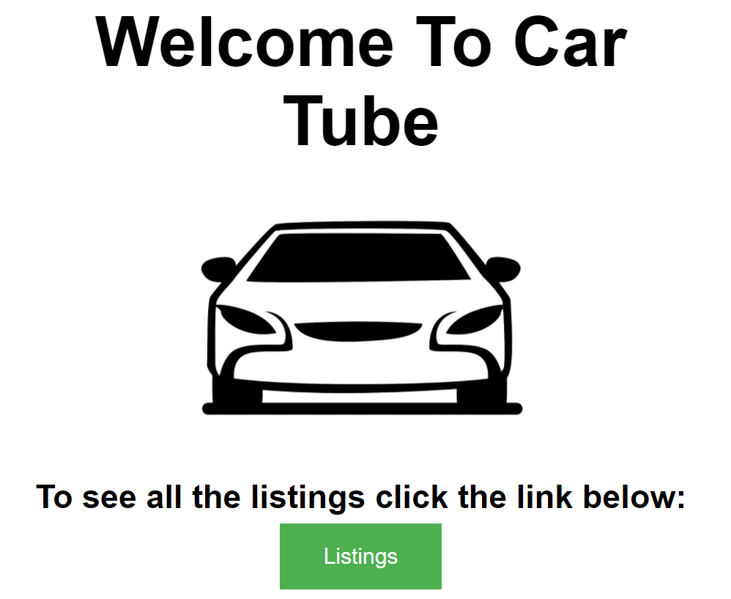

All Listings Page (10 pts)
This page displays a list of all listings in the system. Clicking on the details button in the cards leads to the details page for the selected listing.
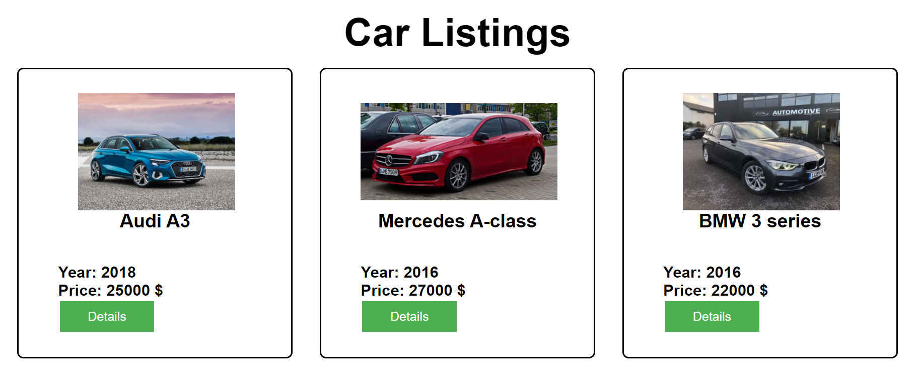
If there are no listings, the following view should be displayed:

Send the following request to read the list of ads:
Method: GET
URL: /data/cars?sortBy=_createdOn%20desc
Required headers are described in the documentation. The service will return an array of listings.

Create Car Listing (15 pts)
The Create page is available to logged-in users. It contains a form for creating new listings. Check if all the fields are filled before you send the request.
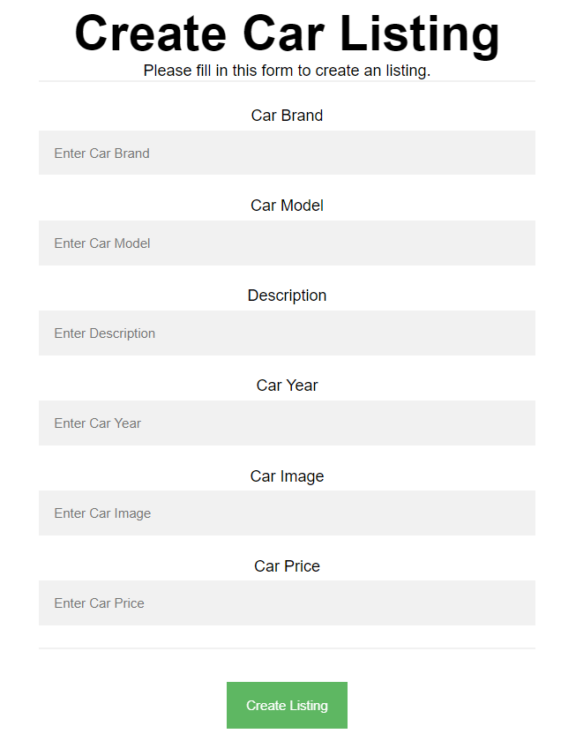
To create a listing, send the following request:
Method: POST
URL: /data/cars
Required headers are described in the documentation. The service expects a body with the following shape:
{
brand,
model,
description,
year,
imageUrl,
price
}
Required headers are described in the documentation. The values of year and price must be positive numbers. The service will return the newly created record. Upon success, redirect the user to the All Listings page.

Details (10 pts)
All users should be able to view details about listings. Clicking the Details link in the car ad should display the Details page. If the currently logged-in user is the creator of the listing, the Edit and Delete buttons should be displayed.
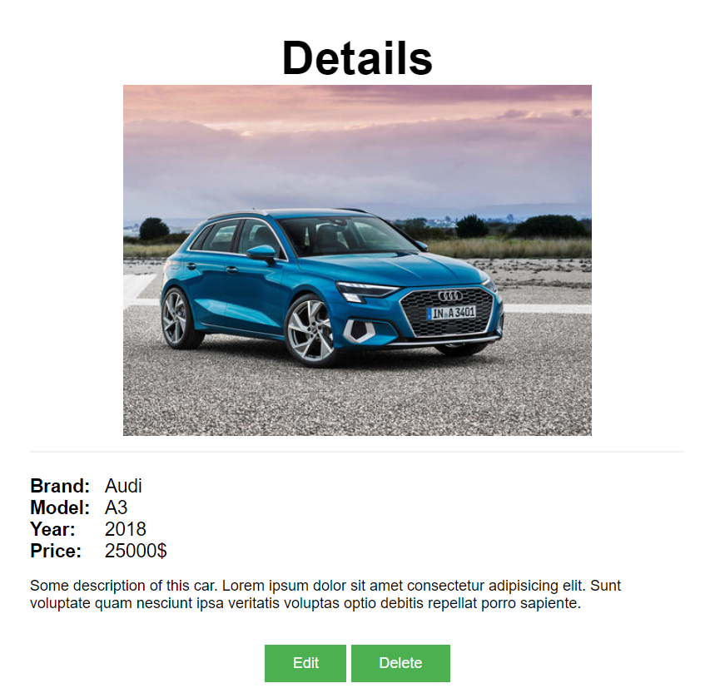
Send the following request to read a single listing:
Method: GET
URL: /data/cars/:id
Where :id is the id of the desired listing. Required headers are described in the documentation. The service will return a single object.

Edit Listing (15 pts)
The Edit page is available to logged-in users and it allows author to edit their own listings. Clicking the Edit link of a particular listing on the Details page should display the Edit page. It contains a form with input fields for all relevant properties. Check if all the fields are filled before you send the request.
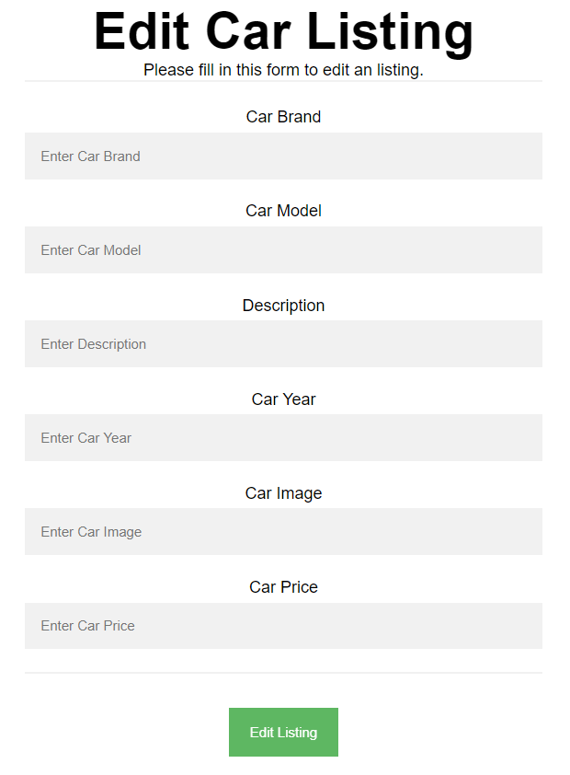
To edit a listing, send the following request:
Method: PUT
URL: /data/cars/:id
Where :id is the id of the desired listing.
The service expects a body with the following shape:
{
brand,
model,
description,
year,
imageUrl,
price
}
Required headers are described in the documentation. The values of year and price must be positive numbers. The service will return the modified record. Note that PUT requests do not merge properties and will instead replace the entire record. Upon success, redirect the user to the Details page.

Delete Listing (10 pts)
The delete action is available to logged-in users, for the listing they have created. When the author clicks on the Delete action on any of their listing, a confirmation dialog should be displayed, and upon confirming this dialog, the listing should be deleted from the system.
To delete a listing, send the following request:
Method: DELETE
URL: /data/cars/:id
Where :id is the id of the desired listing. Required headers are described in the documentation. The service will return an object, containing the deletion time. Upon success, redirect the user to the All Listings page.

My Listings (10 pts)
This page displays a list of all listings made by the current user.
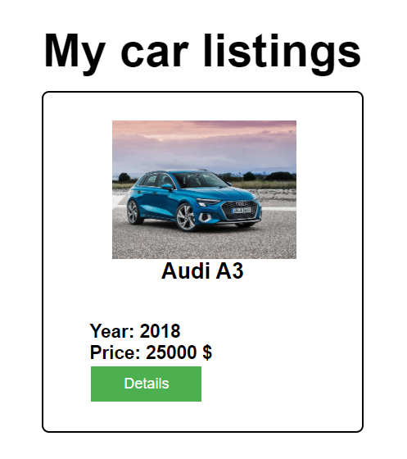
If there are no listings, the following view should be displayed:

Send the following request to read the list of ads:
Method: GET
URL: /data/cars?where=_ownerId%3D%22{userId}%22&sortBy=_createdOn%20desc
Where {userId} is the id of the currently logged-in user.
Required headers are described in the documentation. The service will return an array of listings.

BONUS: Search (5 pts)
The Search page allows users to filter listings by their production year. It contains an input field and, upon submitting a query, a list of all matching listings.
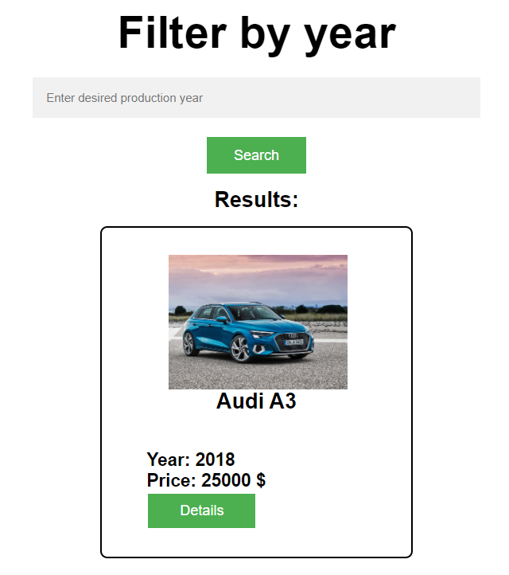
If there are no results, the following view should be displayed:

Send the following request to read a filtered list of ads by their production year:
Method: GET
URL: /data/cars?where=year%3D{query}
Where {query} is the search query that the user has entered in the input field. Required headers are described in the documentation. The service will return an array of listings. If there are no matches, display "No matching listings" instead.

Submitting Your Solution
Place in a ZIP file in your project folder. Exclude the node_modules, server and tests folders. Upload the archive to Judge.
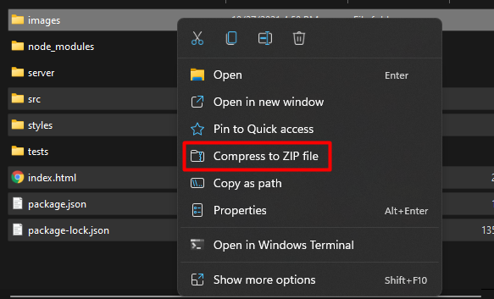
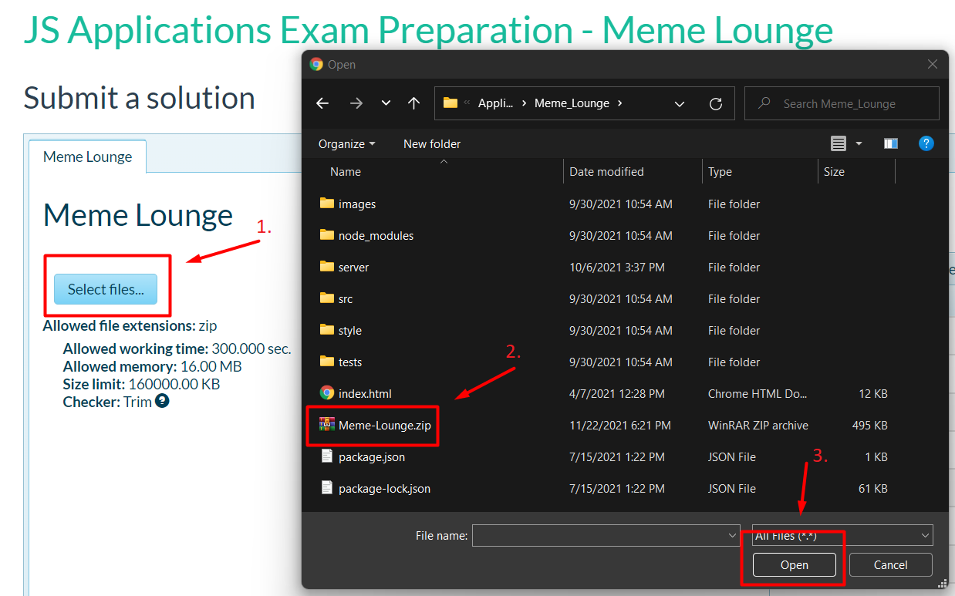
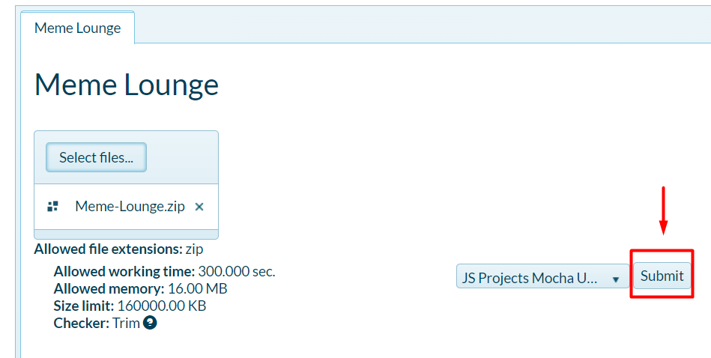
It will take several minutes for Judge to process your solution!
